REPORT 1:
Executive Summary of Structured Clinical Data Analysis
Introduction and Dataset Overview
This report provides a comprehensive analysis of a structured clinical dataset comprising health metrics for a micro-cohort of 12 individuals. The dataset captures six primary physiological variables: Age, Weight, Height, Glucose Level, Diastolic Blood Pressure (DBP), and Systolic Blood Pressure (SBP). The primary objective of this analysis is to evaluate the cardiometabolic health profile of the cohort, identify potential clinical risk factors, and assess the utility of the dataset for broader predictive health modeling. Given the variables included, the data appears to represent a screening cohort for metabolic syndrome, cardiovascular disease risk, or diabetes management.
Descriptive Statistical Analysis and Derived Metrics
A thorough examination of the 12 records reveals significant variability in the physiological profiles of the subjects.
- Demographics: The cohort ranges in age from 21 to 54 years, with a median age of approximately 32 years, indicating a predominantly adult population spanning early to middle adulthood.
- Anthropometrics and BMI: By deriving the Body Mass Index (BMI) from the provided Weight (kg) and Height (m) metrics, critical health indicators emerge. The cohort shows a high prevalence of elevated BMI. For instance, several individuals exhibit a BMI over 30 (e.g., 31.1, 33.2, 30.5, 38.8), classifying them as obese. Conversely, extreme outliers exist, such as a BMI of 52.8 and 44.9, which may indicate severe obesity or potential data entry anomalies regarding height measurements.
- Glycemic Control: Fasting or random glucose levels range from 112 mg/dL to 166 mg/dL. According to standard clinical guidelines (e.g., American Diabetes Association), a fasting glucose level of 100-125 mg/dL indicates prediabetes, while levels ≥126 mg/dL suggest diabetes. Alarmingly, 10 out of the 12 subjects (83.3%) exhibit glucose levels indicative of prediabetes or diabetes, highlighting a severe glycemic control issue within this specific sample.
- Cardiovascular Metrics: Blood pressure readings show significant hypertension risks. Systolic Blood Pressure (SBP) ranges from 110 to 177 mmHg, and Diastolic Blood Pressure (DBP) ranges from 84 to 117 mmHg. Multiple subjects exceed the Stage 2 Hypertension threshold (SBP ≥ 140 or DBP ≥ 90 mmHg), with the most extreme case presenting at 177/117 mmHg, representing a hypertensive crisis risk.
Clinical and Health Implications
The intersection of the derived BMI data, elevated glucose levels, and high blood pressure readings strongly suggests that this cohort is highly representative of individuals suffering from Metabolic Syndrome. The co-occurrence of obesity, hyperglycemia, and hypertension exponentially increases the risk of adverse cardiovascular events, such as myocardial infarction and stroke. The data underscores an urgent need for clinical intervention, lifestyle modification, and pharmacological management for the majority of the individuals represented in this sample.
Methodological Limitations
While the clinical insights are valuable, the dataset presents significant analytical limitations. First, the sample size (n=12) is statistically underpowered for any robust multivariate predictive modeling or population-level inference. Second, the dataset lacks crucial contextual metadata, such as biological sex, fasting status for the glucose tests, medication history, and exact units of measurement. Finally, the presence of extreme anthropometric outliers (e.g., a 25-year-old weighing 76kg at 1.2m tall) suggests potential data quality issues that require rigorous cleaning before integration into larger health informatics systems.
Strategic Recommendations
- Data Augmentation and Cleaning: To make this dataset useful for machine learning or broader epidemiological studies, the sample size must be expanded by orders of magnitude. Concurrently, data validation protocols must be implemented to flag and verify extreme outliers in height and weight.
- Clinical Follow-Up: If this dataset represents a real-world patient panel, immediate clinical outreach is recommended for individuals with SBP > 140 and Glucose > 126 to prevent acute cardiovascular or diabetic complications.
- Feature Expansion: Future data collection should include categorical variables such as sex, ethnicity, smoking status, and family history to allow for more nuanced risk stratification and multivariate analysis.

REPORT 2: Executive Summary of Maternal Mortality Multilevel Analysis in Kenya
Study Background and Strategic Objectives
This report summarizes a comprehensive, large-scale epidemiological study addressing maternal mortality in Kenya. Conventional single-level statistical approaches often fail to account for the nested, hierarchical nature of demographic and health data, leading to biased estimates. To resolve this, the study employed a hierarchical multilevel logistic regression framework. The research was guided by four core objectives: identifying the most informative predictors via the Random Forest algorithm, fitting a multilevel logistic regression model, evaluating model performance through rigorous statistical diagnostics, and applying the validated model for maternal health outcome prediction. Ultimately, this study provides a statistically robust, hierarchically structured predictive framework to inform targeted public health interventions.
Data Integration and Methodological Framework
The study leveraged a massive, integrated dataset combining the Kenya Demographic and Health Survey (KDHS) 2022, the Kenya Population and Housing Census (KPHC) 2019, the Kenya Health Information System (KHIS), and Civil Registration and Vital Statistics (CRVS) from 2010–2023. Following rigorous data cleaning and multilevel multiple imputation under the Missing at Random (MAR) assumption, the final analytic sample included 32,782 women aged 15-49. These women were nested within 28,450 households across all 47 Kenyan counties, allowing for a true three-level analysis (Individual, Household, and County). Survey weights were applied to accurately reflect the stratified two-stage cluster sampling design.
Descriptive Epidemiology and Geographic Disparities
Descriptive analyses uncovered profound geographic and socioeconomic disparities in maternal mortality. The weighted maternal mortality prevalence was 0.33% (approx. 3.3 deaths per 1,000 women). However, sub-national heterogeneity was extreme: the Maternal Mortality Ratio (MMR) ranged from 0 per 100,000 live births in seven counties (e.g., Kiambu, Nakuru, Nyeri) to a staggering 1,203.2 in West Pokot County. Crucially, the place of delivery emerged as a critical determinant of survival. Home deliveries recorded the highest MMR (581.1), vastly outpacing public (241.9) and private facilities (166.5). Individual-level risk factors for mortality included lack of formal education, inadequate antenatal care (ANC), home deliveries, and unskilled birth attendance.
Predictive Modeling and Feature Importance
The Random Forest algorithm successfully isolated the most critical predictors across three hierarchical levels:
- Individual Level: ANC visits (20.08% importance), maternal age (18.36%), age at first birth (14.28%), parity (12.81%), private facility delivery (8.82%), and skilled birth attendance (8.78%).
- Household Level: Distance to health facilities dominated with 56.02% importance, alongside specific wealth quintile categories.
- County Level: HIV prevalence (49.97%), Skilled Birth Attendance (SBA) coverage (25.32%), and county poverty rates (24.08%).
The subsequent three-level multilevel logistic regression confirmed that higher education, increased ANC visits, facility delivery, and skilled attendance significantly reduce the odds of maternal death. Conversely, advanced maternal age, higher parity, greater distance to facilities, and higher county poverty rates significantly increase risk. The null model’s Intra-class Correlation Coefficient (ICC) of 8.2% confirmed significant between-county clustering, justifying the multilevel approach.
Model Evaluation and Performance Diagnostics
The full model demonstrated excellent statistical fit and parsimony (AIC = 3,522.3; BIC = 3,642.8; all Likelihood Ratio Tests p < 0.001). The model explained 16.6% of the variance through fixed effects (marginal R²) and 24.7% when including random county/household effects (conditional R²), with a final ICC of 9.7%. Predictive performance, assessed via repeated 10-fold cross-validation, yielded an Area Under the Curve (AUC) of 0.78, indicating acceptable discriminative ability. While overall accuracy was high at 83.7% and specificity at 89.0%, sensitivity was constrained at 37.2%. This is an expected and acceptable trade-off in predictive modeling due to the rare-event nature of maternal mortality (0.33% prevalence), where the model correctly identifies the vast majority of non-events but struggles to capture all rare positive events.
Strategic Public Health Recommendations
- Targeted Geographic Interventions: Resources must be urgently redirected to high-MMR regions like West Pokot. County-level interventions should focus on poverty alleviation and integrating HIV/maternal health services.
- Eradicating Home Deliveries: Given the massive MMR disparity, community health programs must incentivize facility deliveries and improve the physical accessibility (reducing distance barriers) and cultural acceptability of public health facilities.
- Optimizing Antenatal Care: Since ANC visits were the highest individual-level predictor of survival, policies should enforce minimum ANC contact models and remove user fees for maternal health services.

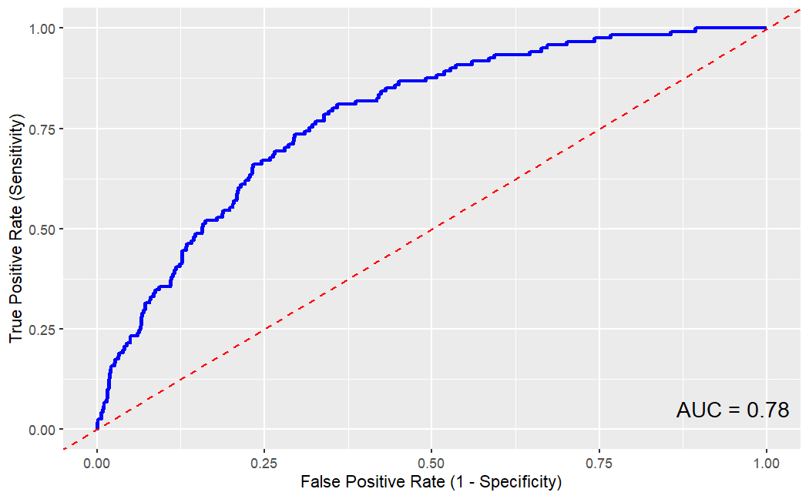
The provided image displays a Receiver Operating Characteristic (ROC) curve, a standard graphical tool used to evaluate the diagnostic ability of a binary classification model. The vertical y-axis represents the True Positive Rate (Sensitivity), and the horizontal x-axis represents the False Positive Rate (1 - Specificity), with both axes scaled from 0.00 to 1.00.
The solid blue line traces the actual performance of the predictive model across various thresholds. It rises steeply from the origin, demonstrating that the model achieves high sensitivity while maintaining a relatively low false positive rate, before gradually plateauing as it approaches the top right corner. The dashed red diagonal line represents the line of no-discrimination, which indicates the performance of a random classifier (an AUC of 0.50).
The model's overall predictive power is quantified in the bottom right corner as "AUC = 0.78" (Area Under the Curve). An AUC of 0.78 indicates acceptable discriminative ability, meaning the model has a 78% probability of correctly distinguishing between a positive case (e.g., maternal mortality) and a negative case. This confirms that the model performs significantly better than random chance and serves as a reasonably effective tool for risk stratification, though it is not yet in the "excellent" range (typically >0.90).

INTERACTIVE DISCUSSION
1. Finance (e.g., Banking, SACCOs, Mobile Money like M-Pesa)
- Structured Data:
  - Transaction logs (timestamps, amounts, sender/receiver phone numbers).
  - Account balances, loan principal amounts, and interest rates.
  - Credit scoring metrics and KYC (Know Your Customer) details like National ID numbers and dates of birth.
- Unstructured Data:
  - Customer service chat logs, emails, and call center audio recordings.
  - Narrative fraud investigation reports or compliance audit summaries.
  - Social media sentiment and text-based customer feedback regarding financial services.
2. Agriculture (e.g., Tea/Coffee cooperatives, Agri-tech platforms like Twiga Foods)
- Structured Data:
  - Crop yield metrics (e.g., kilograms of tea picked per day, maize tons per acre).
  - IoT sensor data from farms (soil pH levels, daily rainfall in millimeters, temperature).
  - Market pricing databases, farmer registration IDs, and subsidy disbursement records.
- Unstructured Data:
  - Satellite imagery and drone footage used for crop health monitoring.
  - Field notes and qualitative observations written or dictated by agricultural extension officers.
  - Voice notes from farmers via WhatsApp or USSD platforms describing pest outbreaks or localized weather impacts.
3. Retail (e.g., Supermarkets like Naivas/Quickmart, informal Dukas, E-commerce)
- Structured Data:
  - Point of Sale (POS) transaction records (SKU numbers, quantities sold, unit prices).
  - Inventory management databases (stock levels, reorder points, supplier lead times).
  - Customer loyalty program data (points accrued, purchase frequency, demographic profiles).
- Unstructured Data:
  - CCTV video footage used for store security and loss prevention.
  - Free-text customer reviews, complaint forms, and product feedback.
  - Email negotiations with suppliers and unstructured product descriptions/images on digital retail platforms.
4. Telecommunications (e.g., Safaricom, Airtel)
- Structured Data:
  - Call Detail Records (CDRs) containing call duration, time, and cell tower IDs.
  - Data usage metrics (megabytes consumed, bundle types, expiration dates).
  - Network performance logs (signal strength, latency, bandwidth capacity per region).
- Unstructured Data:
  - Network engineering incident reports and free-text maintenance logs.
  - Recorded customer support interactions and voice-of-customer surveys.
  - Marketing campaign assets (videos, images) and unstructured social media complaints regarding network outages.
Summary Insight
Just as the Knowledge Base demonstrated that combining structured metrics (like ANC visits or distance to facilities) with unstructured context (like narrative policy recommendations) yields powerful predictive models, Kenyan industries achieve the greatest competitive advantage by integrating both. For example, a telecom company uses structured CDRs to bill a customer, but analyzes unstructured call transcripts to improve customer retention and reduce churn.

